### Sliceform Heart Table Decoration

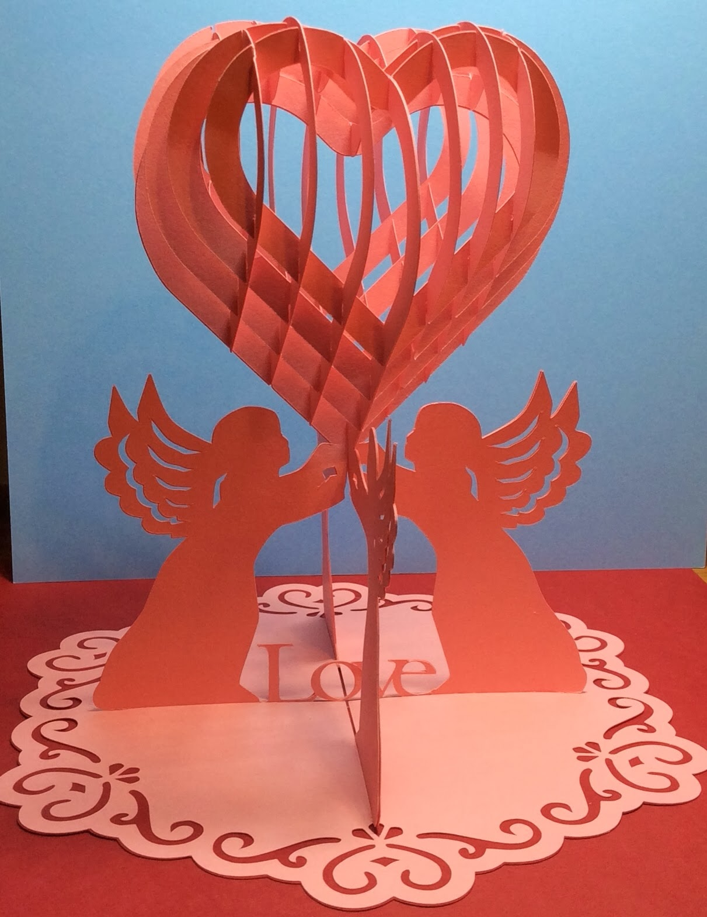

Sliceform Heart Party Decoration

It's time to have a party. This sliceform heart decoration is so pretty, that I want to show it off. It is large enough to make a statement but not too large to overwhelm. This centerpiece could be used for a variety of parties...a birthday party, a Valentine's Day party, a shower party or even a wedding.

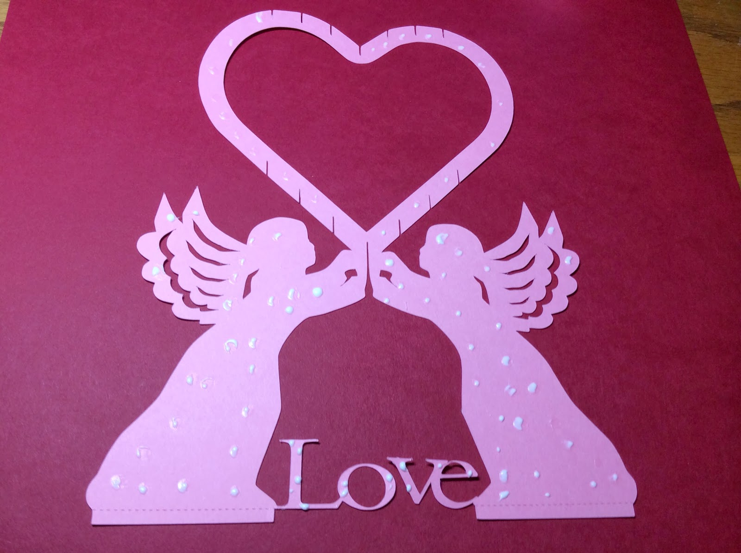

Cut two of the same angel pieces and glue them back-to-back. This is needed to give the cardstock support to hold up the sliceform heart.

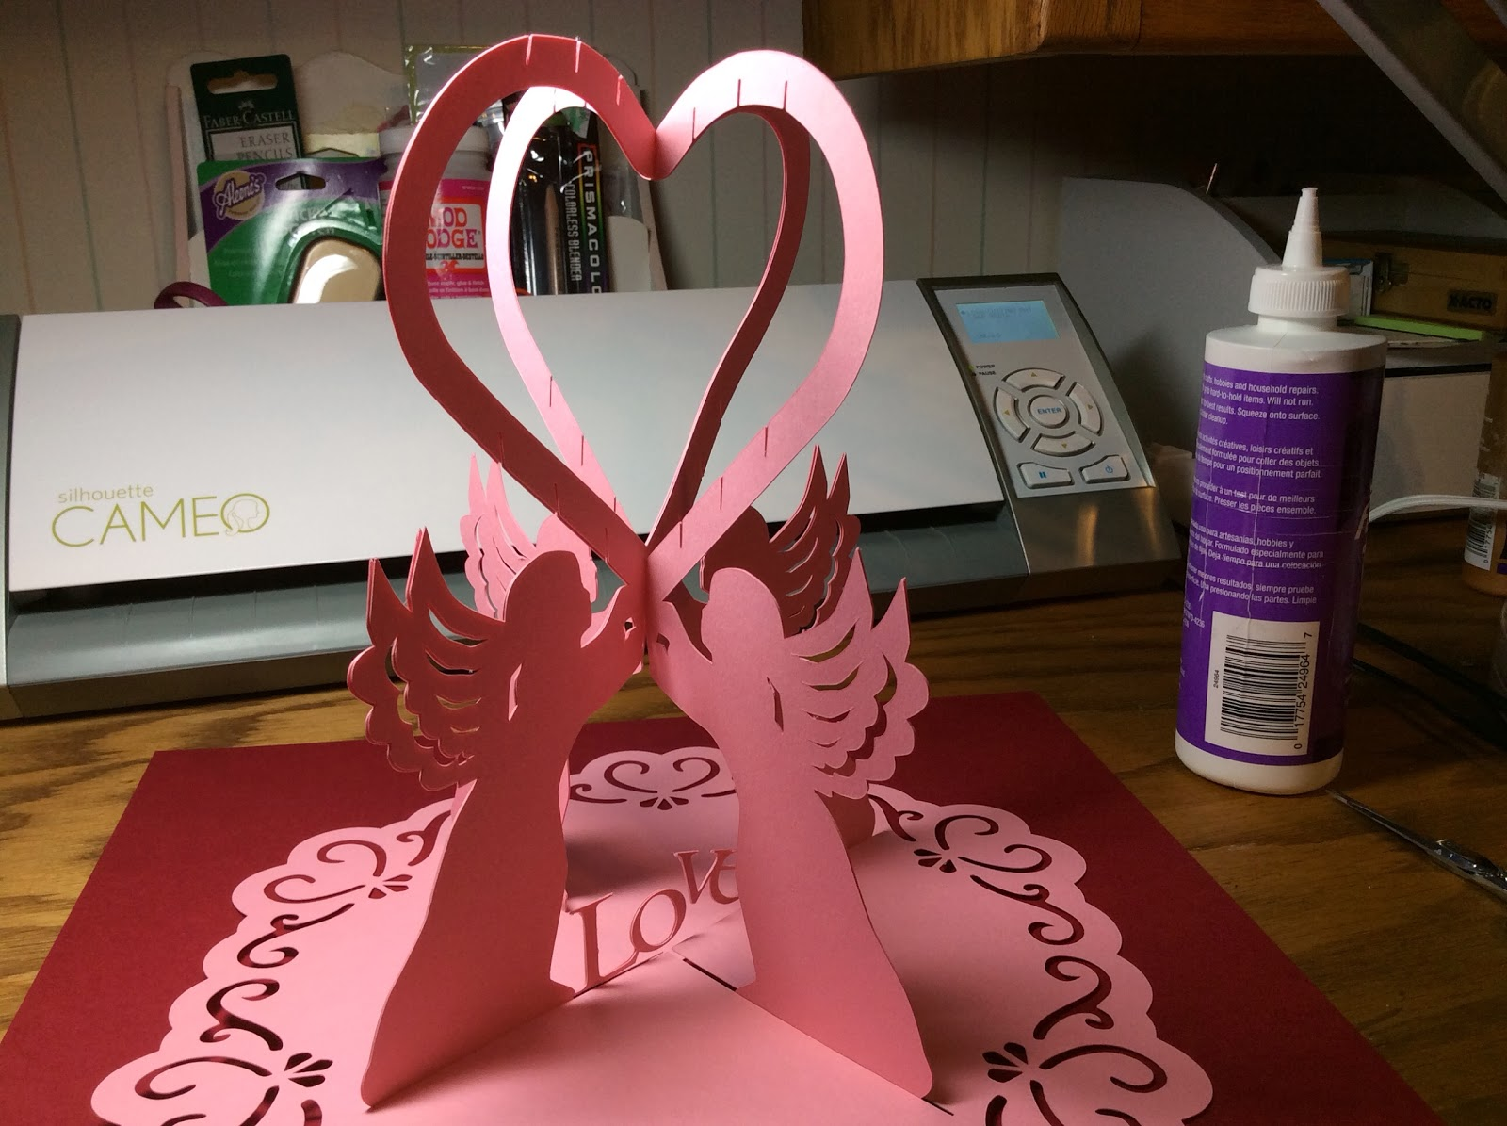

Slide the angel pieces together and place in the base but do not glue to the base until you have completely put the slices of the heart together.

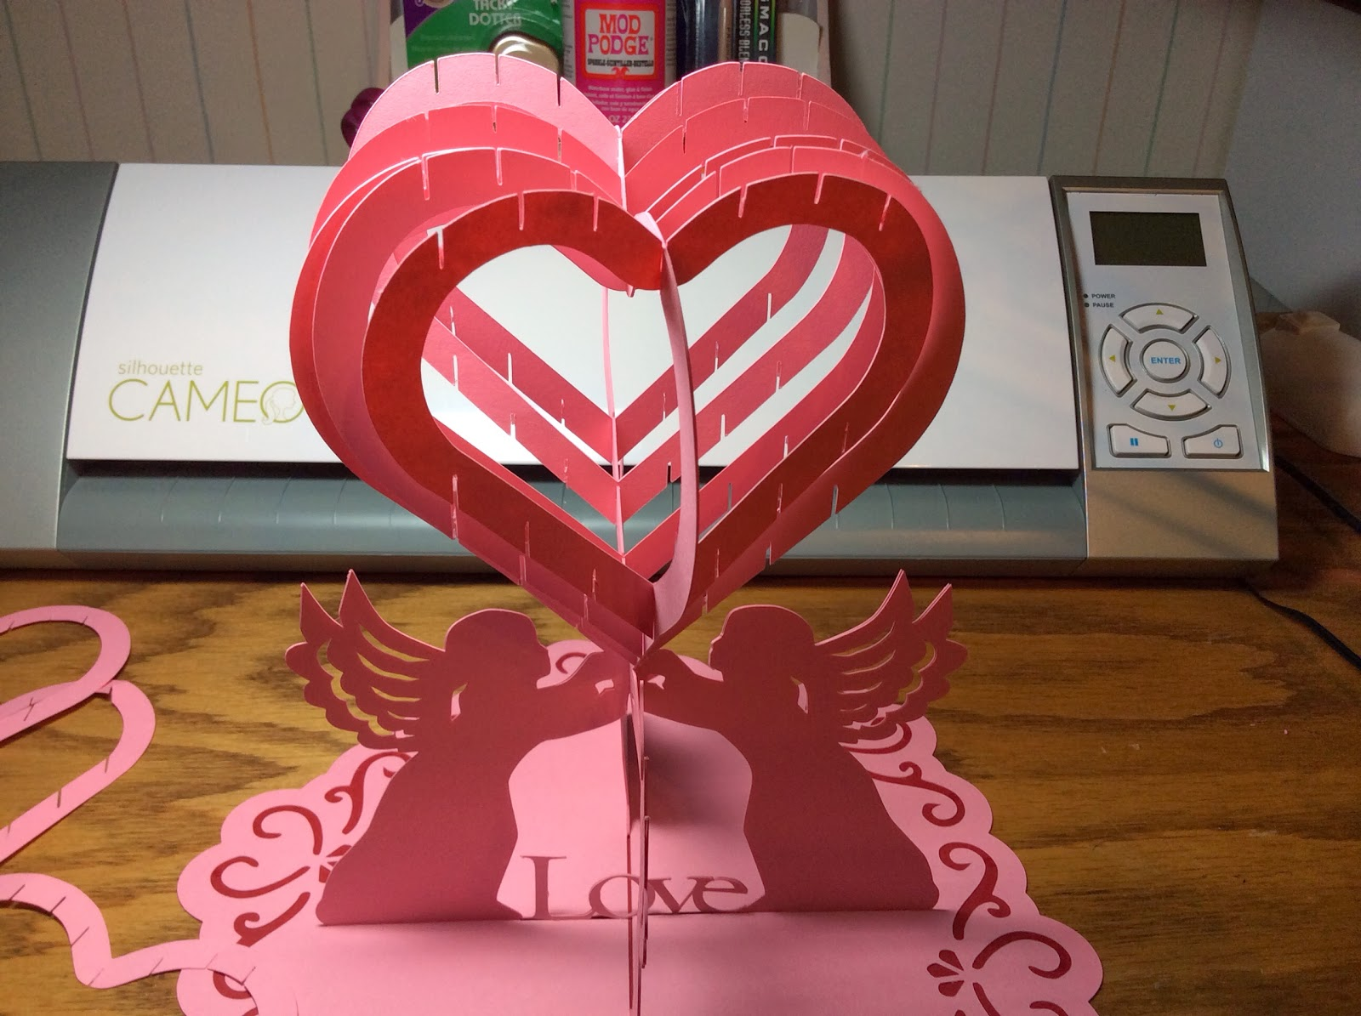

Do all of the upward facing slices first in one direction...as shown in the above picture.

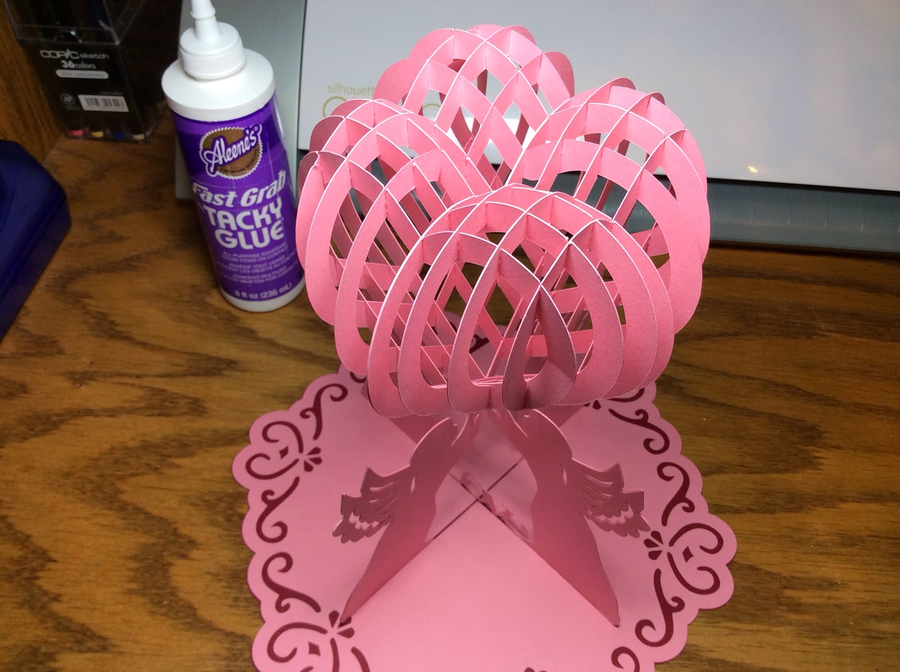

And then the other direction to complete the sliceform heart.

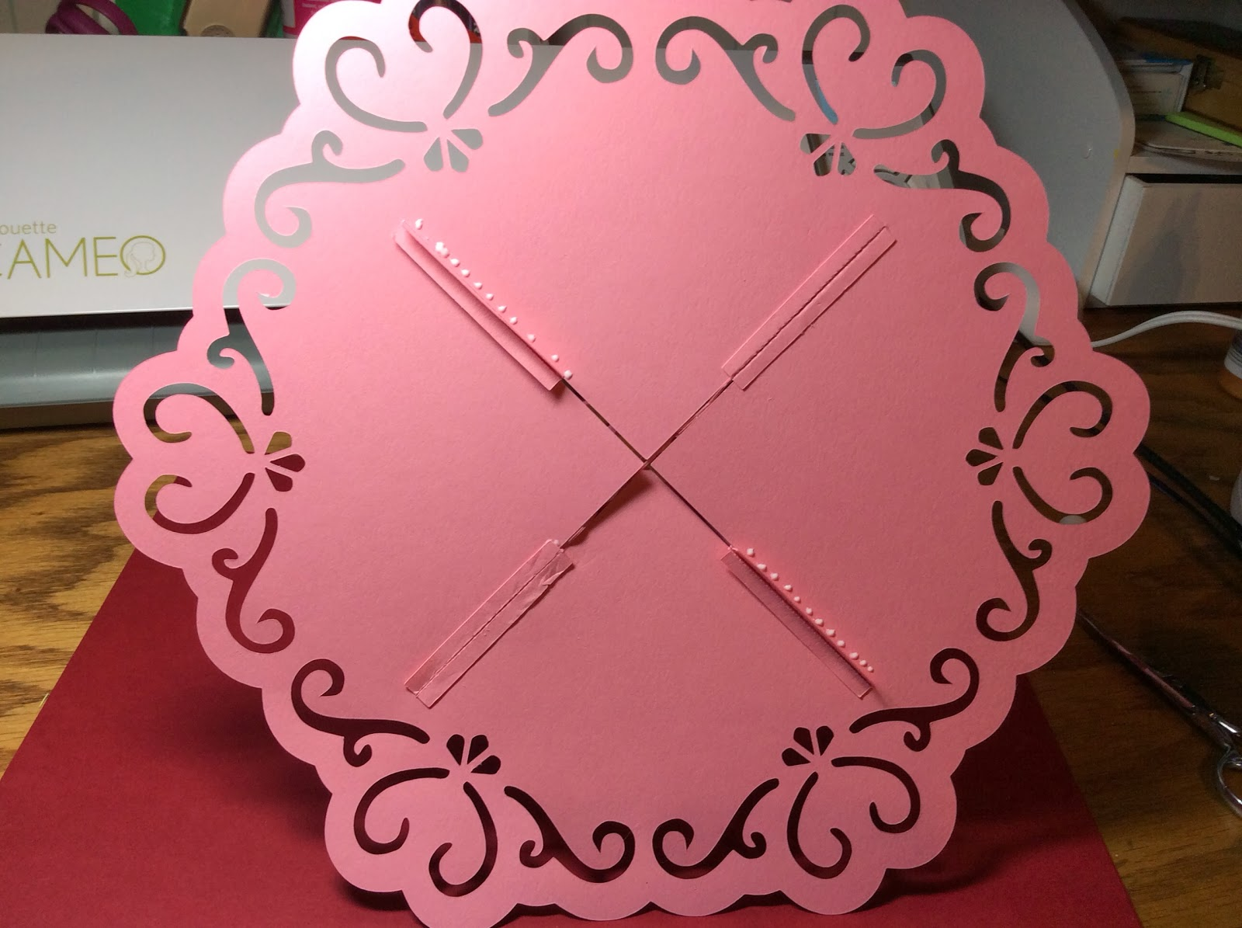

Attach and glue the base as shown. Next, glue the contrasting base to the bottom. (not shown)

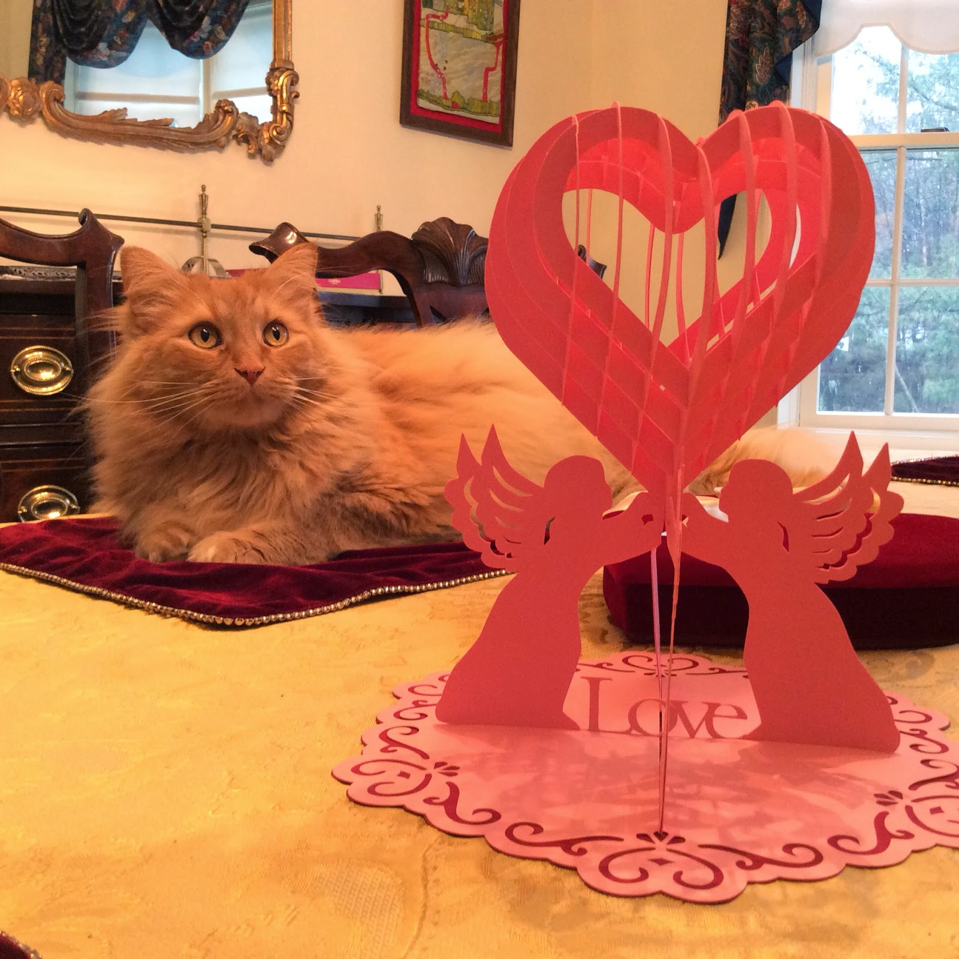

Marley always has to get in the picture. As soon as I put the new placemats on the table, he came running to see what was happening. Of course, he had to sit on the clean placemat. He got up a few minutes later and there was a clump of cat fur stuck to the placemat.

I would love to see a picture of your party decoration if you make this design. Please share a picture of it with me. Thanks!